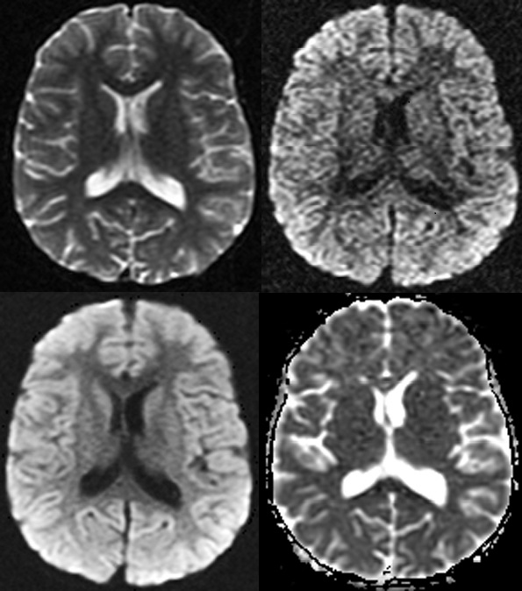

DIFFUSION MR

**submitted by:**

mostafa amr

Kirolos dawood

adel refaat

mostafa abdelmohsen

Table of Contents

Table of Contents 1

List of Figures 3

List of Tables 4

Abstract 5

SEQUENCE OBJECTIVE 6

What is diffusion? 6

DWI objective 7

BASIC PULSE SEQUENCES FOR DWI 7

Spin echo- and stimulated echo-based 7

SSFP diffusion-weighted imaging 9

MRI INSTRUMENTATION 10

Diffusion-weighted imaging (DWI) 10

DWI application 10

Diffusion Tensor Imaging (DTI) 11

DTI application 11

MRI CONTRAST AND DWI 12

Using DWI with the conventional MRI 12

Brain imaging 13

DWI Deficiencies 13

MR FORMATION 14

B0 image 15

DW source image 15

Trace DW image 16

Apparent diffusion coefficient (ADC) map 17

Additional calculated image sets 17

IMAGE QUALITY AND ARTIFACTS 18

Resolution, SNR and contrast Artifacts 18

Artifacts 18

Technological advancement in addressing the challenges 20

PREPARATIONS AND PRECAUTIONS 22

USEFULNESS COMPARED TO OTHER MODALITIES AND SEQUENCES 23

Hepatobiliary pancreatic cancers 24

Bowel disorders 24

Advantages and drawbacks of various diffusion mr techniques 25

Conclusion 27

References 28

List of Figures

Figure1: water molecule movement 6

Figure2: Diffusion-weighted stimulated echo sequence 8

Figure3: One cycle of a diffusion-weighted SSFP sequence 9

Figure4: DWI and the ADC map of a stroke model using rats 10

Figure5: DTI imaging process 11

Figure6: color-encoding technique 12

Figure7: conventional MRI and DWI images and their ADC maps 13

Figure8: Image acquisition module 14

Figure9: B0 image 15

Figure10: DW source image 16

Figure11: Trace DW image 16

Figure12: ADC map 17

Figure13: Additional calculated image sets 17

Figure14: Comparison between DW image and traditional MR image 19

Figure15: DWI image (right) from signal sampling at a single point in 3D q-space (left) 23

List of Tables

Table1: Challenges of DWI and some approaches to address these challenges 21

Table2: Technical requirements of Diffusion MRI Techniques 22

Table3: Advantages and Drawbacks of Diffusion MRI Techniques 26

# Abstract

After its introduction in 1985, diffusion-weighted magnetic resonance imaging has developed and has been influential in the treatment and examination of tissue functions of different tissues, including the cortex, cartilage, and liver. Although brain-related pathology and/or investigation remains the main application, diffusion weighted magnetic resonance imaging (DWI) is becoming a standard in oncology and several other applications. Over the last few years, DWI seems to be an important modality in the diagnosis of acute ischemia in the CNS. There are also a few positive studies on the use of DWI in other regions of the human body, such as the vertebral column or the abdomen. In this overview article includes a concise guide to the diffusion of weighted magnetic resonance imaging, the problems associated and recent developments.

# SEQUENCE OBJECTIVE

## What is diffusion?

Diffusion relates to the unexpected, microscopic motion of water and other small molecules owing to thermal collisions. Diffusion is often defined as Brownian motion, labeled after the Scottish botanist, Robert Brown, who first identified spontaneous oscillations of pollen particles under a microscope in 1827.

For comparison, the rate of diffusion of water molecules at room temperature is 2.2 × 10−5 cm2 / s. That is, on average, the water molecule moves and covers a patch area of 0.000022 cm2 every second as shown in **Fig.1**. Water diffusion relies on the microscopic structural conditions in the tissues, and analysis may offer useful insights into regional morphological and anatomical shifts in disease states.

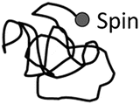

Figure1: water molecule movement

The fastest degree of diffusion happens in free water with no limit. In brain tissue, the borders of cell membranes limit the motion of water to a degree that relies on the mean free path of water molecules. Of starters, in cerebral ventricles, the diffusion of water is fairly unimpeded and the CSF has a strong diffusion coefficient. Gray matter (GM) and white matter (WM) have a weaker diffusion coefficient than CSF owing to their diverse tissue composition.

## DWI objective

Water constitutes a significant proportion of body weight as intra-and extra-cellular fluids in the human body. In biological tissues, the movement of water molecules assumes a sequence of tissue composition and properties. In some pathological conditions, such as acute stroke, this pattern of diffusion is disturbed and the quantity of diffusion changes in the injured region. The irregularities may be observed by observing these variations in diffusion. That can be accomplished utilizing a sophisticated magnetic resonance imaging method named Diffusion Weighted MRI (DW-MRI) or DWI, where the movement of water molecules is used to imagine internal physiology. The image contrast in DWI represents the variation in the rate of diffusion across tissues.

The diffusion of water may be observed or calculated using diffusion-weighted imaging (DWI) technology. DWI is sensitized to random molecular motion of water in tissue by applying magnetic field gradients (diffusion gradients) to the RF pulse sequence. In the DWI series, the diffusion weighting is calculated by the "b-value" variable, which would be in the second unit per square millimeter (s / mm2). High "b-value" results in high diffusion weighting, and no diffusion weighting is produced when b= 0.

On a diffusion-weighted picture, the tissue that contains high levels of diffusing water produces a hypo-intense signal. The chart of the apparent coefficient of diffusion (ADC) of the water molecules can be determined from the diffusion-weighted picture. Diffusion-weighted imaging (DWI) has been repetitively improved to probe random microscopic motion of water protons on a per pixel basis. Such DWI methods have developed far beyond the experimental field to routine therapeutic uses in ischemia which are also the field of study in other diseases, including multiple sclerosis, dyslexia, schizophrenia or trauma. Alterations in proton self-diffusion are an early sign of altered cell homeostasis in acute ischemic stroke[1]. Early identification of such changes may have a significant effect on clinical plans and the medical result for stroke patients[2].

# BASIC PULSE SEQUENCES FOR DWI

## Spin echo- and stimulated echo-based

Merboldt et al. [3] Inserted one diffusion-encoding gradient between the first and the second 90 ° pulse and one after the third 90 ° pulse of the stimulated echo sequence **(Fig.2)** to create diffusion-weighted images. In **Fig.2,** Diffusion-weighting powergradients are performed on the first and third RF pulses. The second RF tips half the spins down down the z-axis. During the mixing time (TM) these spins are only influenced by the somewhat slower-relaxation time. During TMspoils the transverse magnetization free, which may interact with the diffusion-weighted signal when the induced echo is created.

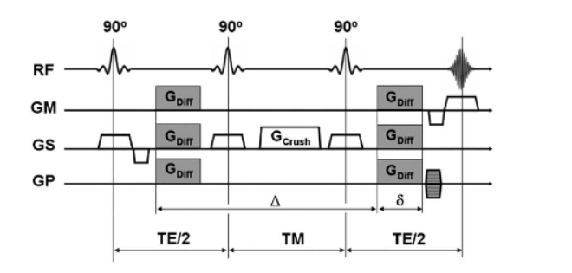

Figure2: Diffusion-weighted stimulated echo sequence

The stimulated echo may be produced by three RF-pulses (note that the RF-pulses must not actually be 90 ° -pulses to create a stimulated echo): the spins are rotated to the transverse plane by the first RF-pulse and lose their phase coherence. The second RF-pulse brings half of the transverse magnetization (i.e. all vector components perpendicular to the phase of the second RF-pulse) from the transverse, z-axis plane. While magnetization is 'stored' along the z-axis (TM), it is only affected by the much slower T1-relaxation process. At the center, after the third RF-pulse, which rotates back into the transverse plane, and after the second precession period (TE/2), a diffusion-weighted induced echo is produced at the time of TE+TM.

Diffusion-weighted induced echo series is of special importance to tissues with brief T2-relaxation periods (e.g. liver) and may often be paired with a number of reading techniques, such as Echo Planar Imaging (EPI) or Spiral Imaging. Diffusion-weighting is primarily determined by the T1-sensitive TM-interval and thus enables one to select brief echo times for a rational diffusion-weighting. It should be kept in mind; however, that the stimulated echoes technically provide only half the signal compared to the spin echoes, with the corresponding signal equation.

## SSFP diffusion-weighted imaging

When a train of equidistant RF pulses with flip angle and TR < T2 is added, a state of steady state free precession (SSFP) may develop; because of the very brief TR SSFP imagery, rapid image creation is feasible. In the presence of magnetic field gradients SSFP imaging has long been known for its high flow and diffusion sensitivity **(Fig. 3)** and has therefore received some attention from a number of research groups[4]. In **Fig. 3,** The ECHO part is usually very responsive to diffusion. For this example chain, all gradients are fully balanced and the overall effective gradient is equivalent in each cycle to create a steady state[5]. To minimize the voluminous motion response, bipolar diffusion gradients can be used to decrease the first gradient moment and even (spiral) navigator echoes can be used[6].

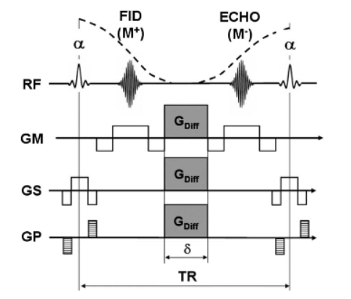

Figure3: One cycle of a diffusion-weighted SSFP sequence

Compared to spin and stimulated echoes, the signal construction in SSFP is, however, a complex mixture between various spin and stimulated echoes, which can be established A multitude of coherent directions, constrained only by the natural T1 and T2 decay periods[7]. This complex signal structure allows the measurement of diffusion very complicated and the diffusion attenuation (b-factor) that differ from tissue to tissue, as the b-factor for this series is often defined by parameters such as relaxation periods and B1-uniformity.

Thus, in comparison to spin echo and induced DWI-based echo, one has to contend not only with 'T2-shine-trough' results, but also with the possibility that b-values are weighted by the underlying stimulation periods and other conflicting variables[8].

# MRI INSTRUMENTATION

## Diffusion-weighted imaging (DWI)

The water diffusion can be detected or measured using the diffusion-weighted imaging (DWI) technology. DWI is sensitized to the water molecular motion in tissue by applying magnetic field gradients (diffusion gradients) in the RF pulse sequence. In a DWI sequence, the diffusion weighting is determined by a parameter called “*b*-value,” which is in the unit of second per square millimeter (s/mm2). High “*b*-value” generates high diffusion weighting, and no diffusion weighting is generated when *b* = 0. On a diffusion-weighted image, the tissue that contains high diffusing water generates hypointense signal[9].

## DWI application

The use of DWI on neurological studies has been shown that a wide range of neuropathology causes DWI signal changes. One of the most successful applications is in the stroke study. *T*1- and *T*2-wt MRI failed to detect the ischemic lesion in acute stroke. Oppositely, the lesion can be detected using DWI. DWI can reveal the immediate temporal changes in ADC that occur upon induction of ischemia. **Fig. 4** shows the DWI and the ADC map of a stroke model using rats[10]. The ischemic region has elevated DWI signal intensity indicating decreased water diffusion in this region. ADC map calculated from the DWI shows decreased ADC in the same region.

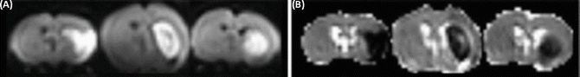

Figure4: DWI and the ADC map of a stroke model using rats

The underlying pathology of the ADC change during ischemia remains unclear. Several theories explain the observation. One of them is the cell swelling theory. This theory assumes that water diffusion is slower inside cells than in the extracellular space. The disruption of blood supply in stroke induces cell swelling (cellular edema). Water molecules then spend more time diffusing in swollen cells, and thus decreasing ADC. Another theory assumes that the changes in cell membrane permeability may contribute to the ADC reduction. A loss of active intracellular water transport with energy failure may be another cause of the decreased water diffusion.

## Diffusion Tensor Imaging (DTI)

DTI is an extension of DWI. Diffusion is a three-dimensional process. In a uniform environment, it is isotropic in all directions and can be represented by a sphere. If water molecule movement is restricted in certain directions, the diffusion becomes anisotropic, represented by an ellipsoid. For example, in fiber-like cell structures, such as white matter tracts, the diffusion is relatively free along the long axis of the fiber tract, but restricted in the other two dimensions. The diffusion in cellular structures is described mathematically by a tensor. A tensor is a 3 × 3 matrix. The tensor of diffusion[11] is measured using DTI with diffusion gradients in appropriate strength. After a series of mathematical manipulations, the axes of the ellipsoid diffusion and the diffusion magnitudes along the axes can be calculated.

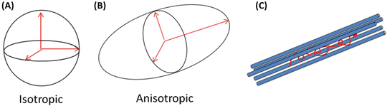

Figure5: DTI imaging process

## DTI application

Apparently the principal axis (the axis with the maximum diffusion magnitude) of the diffusion ellipsoid points to the preferred diffusion direction. It is reasonable to think that for WM, the favorite diffusion direction is along the WM tracts, and thus the principal axis is parallel to fiber tract orientation. Several methods display the principal axis, one of which is the so-called color-encoding technique. In the color-encoding technique, the three components along the directions of the principal axis are encoded with the primary colors (red, *x* component; green, *y* component; and blue, *z* component) and the brightness is scaled by an anisotropy index such as FA. **Fig. 6** explains this method on multiple image slices of a mouse brain where the brightness was scaled by the FA value[11].

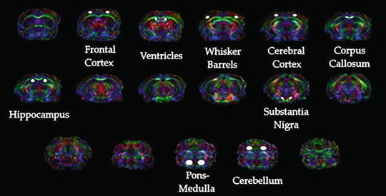

Figure6: color-encoding technique

# MRI CONTRAST AND DWI

Conventional MRI system changed a lot since it was created through diagnose and investigation of many different kinds of tumors in any organ of the body. Before MRI we were not able to detect any tumor[12]. The process was through very hard method to figure out the body tumors, however with time and all technologies which we already have today we could improve the image of MRI as unfortunately it was not very precise on organs like brain and liver. The difference between DWI and conventional MRI that DWI illustrates the contrasts of the region using the diffusion of water in cells as any region even it was empty it has differences in tissues and microbodies will draw the contrast of the region which will give us a map like.

## Using DWI with the conventional MRI

Taking a case like the stroke which arises from ischemia in case like this using MRI without DWI will not be helpful as it will detect the problem after couple of hours and possibly more, but using DWI will detect the problem only in half an hour and maybe less than that. The point is MRI good with tumors and big tissues differences but in a case like stroke we will not figure the problem, however DWI detects the changes in water in tissues so any stroke or different behavior will change the map which is drown by DWI. Unfortunately we can’t replace MRI with the DWI totally as it will not be very precise on the levels of tumors it will give a precise map for the region and the hyper and hypo intense signals based on the diffusion, however it will not give anatomical information about the tumor like the MRI sequence[13].

Using both MRI and DWI together makes the image more complete and precise. Studies show that combining both of them helps in differentiating between benign and malignant tumors which only MRI sequence was not able to differentiate between them correctly before DWI. Another case is prostate cancer. A study by heider et al explains that using both of conventional MRI and DWI together gives a more precise and detailed imaging. Another benefit of DWI is that it does not require any hardware system; therefore it is very easy to use it on a MRI device to get the best result. **Fig. 7** shows a T2WI (conventional MRI) images and DWI images of a prostate cancer patient. Figure B is DWI and C, D are corresponding ADC maps in gray and color scale.

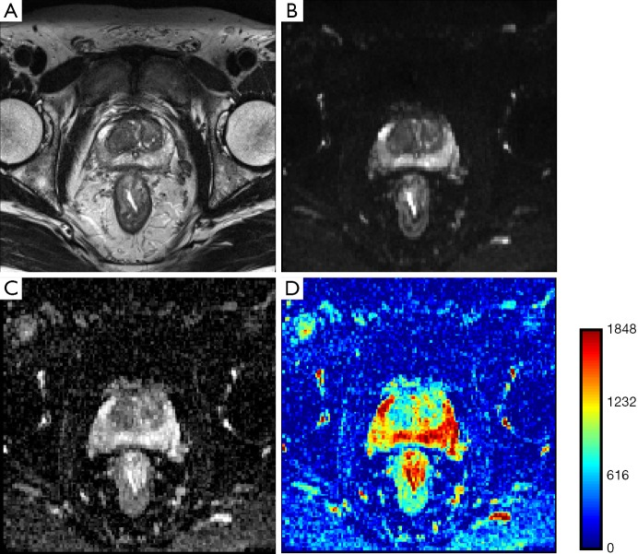

Figure7: conventional MRI and DWI images and their ADC maps

## Brain imaging

Diffusion tensor imaging (DTI) is one of the main branches of DWI. Its process is by taking several images from every direction of the region to develop the tensor image. Using DTI enables us to get better images when it comes to fiber tracking. It also helps a lot in studying the white matter of brain depending on the diffusion which assumed to be highest parallel to the tract so it will help in studying the pathways of the brain.

## DWI Deficiencies

Theoretically DWI is a perfect tool for tumors and detecting any small change in the region we want to explore. Unfortunately practically the image of DWI depends on a lot of factors which may reduce its efficiency like the field homogeneity, slow gradient changes and the hardware limitations. Also low strength scanners leads to lower resolution which is one of the main reasons that DWI is not efficient alone and needs MRI sequence.

# MR FORMATION

Modern diffusion-weighted (DW) sequences all trace their origin to the echo pulsed gradient spin (PGSE) technique developed by Edward Stejskal and John Tanner[14] in the mid-1960. As shown in the diagram right, symmetric, strong diffusion-sensitizing gradients **(DG's)** are applied on either side of the 180°-pulse. The stationary spin phases are uninfluenced by the DG pair as any phase accumulation from the first gradient lobe is reversed by the second. However, diffusing spins move around in various locations results difference between the first and second lobes, drop out of phase and lose signal.

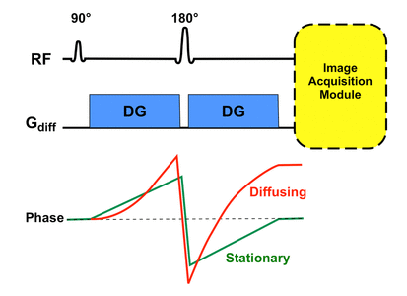

Figure8: Image acquisition module

Immediately after the second DG a module for image acquisition is played out. That is usually an echo-planar sequence with phase and frequency gradients oscillating rapidly generating multiple echoes of gradients. Generally speedy image acquisition is needed minimizing impacts of bulk motion (such as vascular pulsations) on DW images. Other modules (such as the rapid spin echo) are possible, but are currently not as widely used.

Modern DWI implementations maintain the core features of the original PGSE technique used by Stejskal and Tanner[14] with some modifications[15]. All commercial DWI sequences use some form of fat suppression method to suppress artifacts from chemical shifts. This can be a chemical-selective fat saturation pulse or a non-selective inverting pulse "STIR-like" applied immediately before the 90 ° pulse. Alternatively, it is possible to selectively tune the 90 ° -pulse itself to only excites water protons. Suppress eddy currents and decrease artifacts of spatial distortion[16] a "twice-refocused" PGSE sequence can be used. This technique uses a second 180 ° -refocusing pulse at[17] the use of bipolar (rather than unipolar) DG's is a third common modification to reduce eddy current artifacts.

With the core pulse sequence defined as above, DW images and their associated maps are automatically generated with the following steps[18]:

## B0 image

The DW pulse sequence is initially executed with the DG turned off or set the value to very low. This generates a set of T2-weighted **b0 ("b-zero") images** which will serve as the basis for the later calculated maps. (**B50 images** are also collected for abdominal imaging, the low but non-null amplitude gradient helps to block signal in vessels). **Fig. 9** shows an example of b0 images.

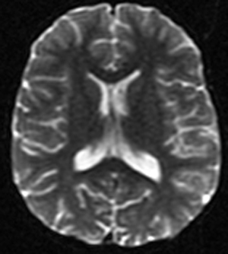

Figure9: B0 image

## DW source image

The DW sequence is then executed individually or in combination with the DG's turned on and at different strengths. It produces **DW source images** that are sensitized to diffusion in several different directions. **Fig. 10** shows an example of DW source images.

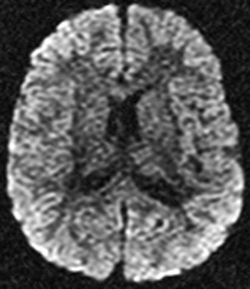

Figure10: DW source image

## Trace DW image

A collection of **Trace DW images**, the first-line images used for clinical diagnosis, are paired with the DW source images. **Fig. 11** below shows an example of Trace DW images.

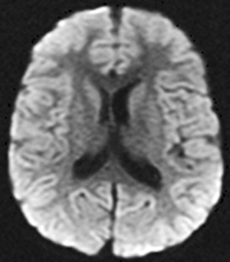

Figure11: Trace DW image

## Apparent diffusion coefficient (ADC) map

Then a map of the **Apparent Diffusion Coefficient (ADC)** is calculated using the b0 data and the source images. The ADC chart is used to explain any anomalies found on the trace images. **Fig. 12** below shows an example of ADC map.

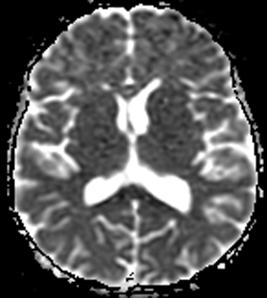

Figure12: ADC map

## Additional calculated image sets

Optionally, more advanced processing may be done, generating additional computed image sets for analysis. These may include **exponential ADC maps,** **fractional anisotropy images**, **principal diffusion direction maps**, and **fiber tracking maps**. **Fig. 13** illustrates these advanced processing and the additional image sets.

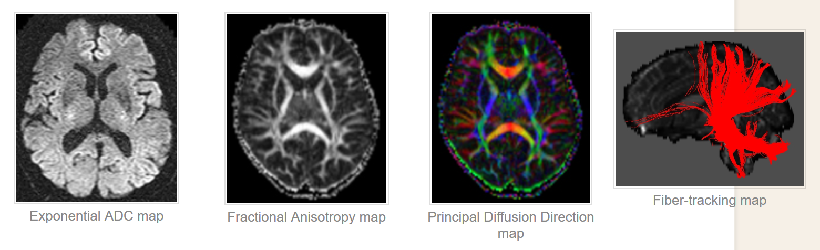

Figure13: Additional calculated image sets

# IMAGE QUALITY AND ARTIFACTS

## Resolution, SNR and contrast Artifacts

DW images tend to be of lower resolution than conventional MR images such as T2WI. This is due to multiple factors such as low resistance scanners, faster image acquisition methods such as Single-Shot Echo Planar Imaging and limitations of general acquisition parameters such as field of view (FOV) slice thickness etc. Lower strength scanners contribute weaker signals to the image co pared to high-resistance scanners and thus provide lower resolution than low-resistance scanners. Fast acquisition methods such as SS-EPI focus on image acquisition in a very short time before the complete decline of the signal and thus limit the maximum achievable resolution of DW images. Also related to spatial resolution are general MR acquisition parameters such as FOV, slice thickness, matrix size etc... Increasing FOV but maintaining the same matrix size would reduce image resolution (in-plan spatial image resolution can be calculated by dividing FOV with matrix size) and increase matrix size if FOV remains constant would increase in-plan resolution. In general, the resolution along the direction of the slice (through-plane) is lower than the direction of the image (in-plan). The maximum resolution that can be achieved by optimizing these parameters is therefore constrained by the scanner's hardware limitations. In radiotherapy planning, low resolution can be a challenge since DW images are used in conjunction with T2-weighted images along with ADC maps, which are typically of higher resolution. Despite the disparity between the respective resolutions, if ADC and T2WI were to be superimposed due to ADC / DWI's low resolution, it would overestimate the area of the lesion because of its lower resolution. And in general, images with higher resolution are preferred because compared to images with lower resolution; they offer more data and precise details.

DW images also suffer from low SNR due to the presence of large amounts of noise, in addition to the low resolution. Image contrast is also a crucial issue, since higher contrast is very beneficial in precisely delineating regions of abnormality using diffusion coefficient values from ADC maps. Lower SNR and contrast-to-noise-ratio (CNR) will restrict the capability of accurate interpretation of ADC maps and DW images.

## Artifacts

DW images are often susceptible to a variety of artifacts such as distortion, ringing, etc. that arise from a host of factors. Distortion is one of the biggest artifacts in DW images. Distortion of the images may occur due to field inhomogeneity and magnetic susceptibility variations in the area being imaged.

In the early 2000s, widely used 3 T scanners were introduced and quickly adapted by their ability to attain higher spatial resolution, higher SNR, and better contrast than 1.5 T machines. However, increased field strength in the image contributed to higher artifacts related to magnetic susceptibility. The magnetic field B1, in which the patient is placed, becomes more inhomogeneous as the field strength increases, thus contributing to more errors in image acquisition[19]. Sequences like EPI require very homogeneous magnetic fields to ensure that the spins of the proton adhere to the spin rate and do not dephase, thus ensuring accuracy of the signal. However, in some instances, such as at air-tissue interfaces, protons at the interface undergo phase change that is different from the expected due to variations in magnetic susceptibility resulting in geometric distortion of the image. **Figure 14A** shows an image weighted by T2, and **Figure 14B** shows a phantom's corresponding DW image. In the DW image**, Figure 14B**, the phantom is put in the air and scanned because of the distortion occurring around the edges with air-interfacing.

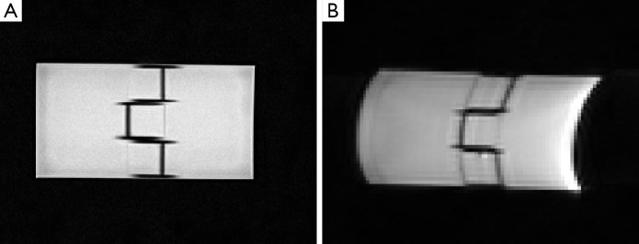

Figure14: Comparison between DW image and traditional MR image

This distortion can also be observed when imaging is done in metal implant tissues, due to region-wide field variation. The gradient system may also cause artifacts related to this susceptibility which could introduce magnetic field inhomogeneity. Strong and rapidly switching gradients because local currents, called eddy currents, which in effect create their own local magnetic fields and thus disrupt homogeneity in the field. Such eddy currents help to distort and shift images by manipulating the gradient strengths encountered by spins[20], which affect accurate interpretation of the image and ADC estimation and clinical diagnosis thereby. Other artifacts such as ghosting can also be a result from eddy currents[20].

Apart from distortion, sequences of EPIs are sensitive to motion, whether microscopic or macroscopic, resulting from different factors. Macroscopic motion results in severe motion-related artifacts causing the DW image to ghost or blur. This could greatly affect the measurements of diffusion for DW imaging, and could render incorrect data. Although precautions can be taken to minimize the voluntary movement of patients, involuntary movements such as breathing, blood flow or mechanical vibrations resulting from the scanner's patient table remain unavoidable.

## Technological advancement in addressing the challenges

DW images often have lower image quality compared to other traditional MR images due to problems with image quality such as distortion, noise, poor resolution and the presence of artifacts, most of which result from the use of faster image acquisition techniques such as EPI, necessary to capture the diffusion signal until it becomes null.

Most of these problems can be solved by altering DW-MR protocol variables such as echo time (TE), gradient strengths, adjusting techniques for image acquisition etc. Broadly speaking, the approaches to address the inherent challenges associated with DWI fall into four categories: hardware upgrades or enhancements, use of contrast agents, optimizing acquisition parameters, and post-processing techniques based on software. None of these approaches address all of the challenges individually, as they may present their own challenges such as increased acquisition time, etc.

|  |  |
| --- | --- |
| Challenge | Some common approaches to address challenges |
| Low resolution | |  | | --- | | Hardware improvements | | Increasing field strength of scanners | | Multi-shot sequences | | Post-processing | | Interpolation techniques; super-resolution reconstruction | |
| SNR | |  | | --- | | Hardware improvements | | Increasing field strength of scanners; High strength gradients | | Multi-shot sequences | | Acquisition parameters | | Averaging | |
| Contrast Acquisition time | Contrast agents   |  | | --- | | Hardware improvements | | Increasing field strength of scanners; high strength gradients | | Single-shot sequences | | Parallel imaging | | Acquisition parameters | | Optimal TR, TE, number of b-values | |
| Distortion from susceptibility differences and eddy currents | |  | | --- | | Hardware improvements | | Increasing field strength of scanners; high strength gradients; shimming coils | | Non-EPI based sequences | | Calibration scans and pre-emphasized pulses | | Acquisition parameters | | Increasing receiver bandwidth or decreasing peak gradient amplitudes | | Post-processing | | Acquiring field maps and correction algorithms | |
| Motion artifacts | |  | | --- | | Hardware improvements | | Single-shot EPI; Non-EPI based sequences; | | Cardiac and Respiratory triggering or bi-polar gradient pulses Navigator based and readout-segmented acquisition methods | | Acquisition parameters | | Averaging | |
| ADC accuracy | |  | | --- | | Acquisition parameters | | Optimal number of b-values | | Diffusion modelling in tissue | | Post-processing | |

Table1: Challenges of DWI and some approaches to address these challenges

# PREPARATIONS AND PRECAUTIONS

In a DWI sequence diffusion sensitization gradients are applied at both sides of the 180° refocusing pulse. The parameter which decides the diffusion weighting is called “*b* value” and is represented in s/mm2. It is proportional to the square value of the duration and amplitude of the gradient applied. Diffusion is evaluated on trace images qualitatively and quantitatively by the parameter which known as apparent diffusion coefficient (ADC). The tissues with restricted diffusion are bright on the trace image and hypo-intense on the ADC map[18].

The algorithms which used in the acquisition of DWI make several assumptions, *e.g*., infinitely rapid gradient changes, perfect field homogeneity, and RF pulses perfectly shaped, *etc*. However, with the accessible technology, gradient coils are capable of generating gradient magnitudes and switching rate of the order of 40 mTm-1 and 200 Tm-1·s-1 respectively. Such discrepancies limit DWI accuracy and lead to lower quality of image and image artifacts. The main limitations of DWI are experienced in body imaging and are hugely due to being an Echo-Planar Imaging sequence. DWI is vulnerable to different artifacts, *e.g*., T2 black out, ghosting, T2 shine through, distortions and blurring. Tissues with very long relaxation times may tend to keep signal on high *b* value images. This is defined as “T2 shine through” effect. The corresponding bright signal of such lesions on the ADC map helps to distinguish it from restricted diffusion, which looks dark on ADC maps. T2 blackout effect is the term used on the ADC map for low signal because of a lack of sufficient water protons and not restricted diffusion. For such an effect, the diagnostic sign is the low signal on T2 weighted fat saturated images.

|  |  |  |  |  |  |  |  |
| --- | --- | --- | --- | --- | --- | --- | --- |
| Display | Post processing | Acquisition  Time  (min)* | Maximal  Gradient  Strength  (sec/mm2) | No. of  Gradient  Directions | 3.0 T and  High Gradient  Strength  Capabilities |  | Technique  and  Reference |
| Gray-scale sections | None | 1–3 | ≤1000 | 1 | Optional |  | Diffusion weighted imaging |

Table2: Technical requirements of Diffusion MRI Techniques

Another disquieting limitation of DWI is the questionable reproducibility of ADC values. ADC values can differ even if the same MR system is used. This variability was attributable to the low SNR inherent, distortions and artifacts related to SS EPI sequence. During EPI sequence, diffusion gradients rapid on/off transition leads to eddy-current related distortions leading to image degradation and systemic errors in calculations of ADC.

# USEFULNESS COMPARED TO OTHER MODALITIES AND SEQUENCES

MRI provided an excellent contrast resolution not only from tissue (proton) density, but also from tissue relaxation properties. After primary focus on T1 and T2 relaxation properties researchers investigated other methods for generating contrast using other properties of molecules of water. Diffusion weighted imaging (DWI) was the result of such researchers' efforts as Stejskal, Tanner and Le Bihan[21].

Diffusion-weighted MRI is considered as the simplest form of diffusion imaging. DWI is considered as one of the components required to reconstruct the complete probability density function as in diffusion spectrum imaging. Also, DWI is the outcome, which is unprocessed, of a single pulsed gradient SE sequence being applied in single gradient direction, and it matches up in q-space to one point. Although such an image is fairly simple, it contains some diffusion information. In **Fig. 15**, the right splenium of the corpus callosum appears dark, whereas the left splenium appears bright. In regions like the right splenium, in which the main direction of diffusion is aligned with the diffusion gradient applied, the signal intensity decreases markedly and the region appears on the image darker. Diffusion in the ventricles is free and substantial in all directions including the direction of applied gradient, and so the whole of the ventricles appears dark. In spite of its simplicity, DWI is frequently used in stroke investigations. Indeed, in an acute stroke, increased water mobility restrictions is produced by the local cell swelling and hence, bright image appearance because of high signal intensity in the lesion area.

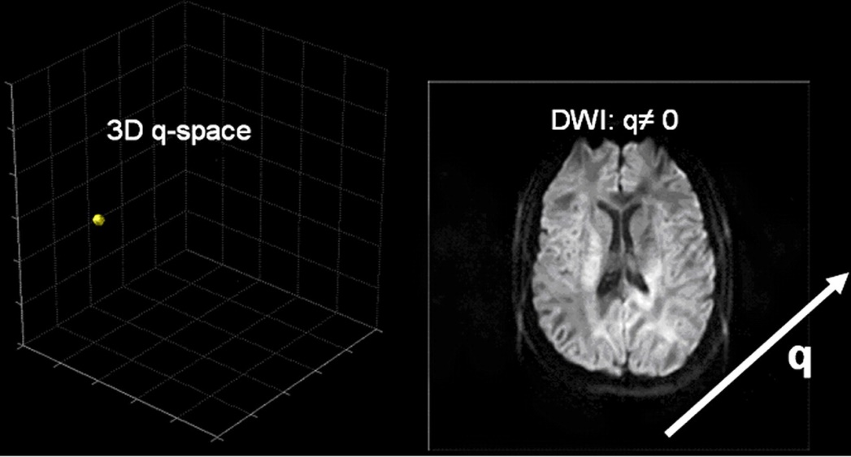

Figure15: DWI image (right) from signal sampling at a single point in 3D q-space (left)

The advantage of DWI is the shortness of the acquisition time, because one image only is required. And there are many other advantages of DWI compared to other sequences, such as:

* DWI may be useful to demonstrate persistent or progressive tumor despite the lack of contrast enhancement. Pseudo-progression is seen in the edema setting associated with the inflammatory response, rather than the true tumor progression.
* DW-MRI is applied in neoplasms of the neck and head.
* Diffusion weighted image could be used to distinguish malignant from benign and inflammatory lung lesions and helps to differentiate small cell cancers from non-small cell cancers.
* DWI can differentiate benign renal cysts easily from solid neoplasms.
* DW MRI's exquisite sensitivity to microstructural changes allows us to detect the abnormalities long before conventional image changes.
* DWI improves endometrial and cervical tumors diagnosis.
* DW MRI is particularly useful in determining the depth of myometric invasion in endometrial cancer patients**.**

## Hepatobiliary pancreatic cancers

DWI is useful in the characterization and detection of focal liver lesions and can be used as an alternative to Gadolinium-enhanced MRI in renal dysfunction patients. DW MRI clinical applications include the monitoring of treatment response and prognosis in patients receiving systemic and focal ablative pancreatic and hepatic malignancies therapies. Hardie et al compared the usefulness of DWI in liver metastases detection. They reported that diffusion weighted image has 66.3% sensitivity compared to 73.5% for CE-MRI and therefore it can serve as a useful alternative for this purpose. DW MRI in diffuse hepatic parenchymal disease such as hepatic fibrosis and non-alcoholic fatty liver disease has been investigated.

## Bowel disorders

DWI is useful and helpful for detecting nodal and hepatic metastases, colorectal cancer and predicting, for locally advanced rectal cancer, the response after radio-chemotherapy. DWI detects changes in lesion vascularity induced by therapy during anti-angiogenic therapy before significant size changes are evident. DWIBS has been reported as a useful instrument for detecting colorectal cancer nodal metastasis. Besides its usefulness in abdominal malignancies, DWI was also found to be helpful in inflammatory bowel disease. Qi et al reported that diffusion weighted image combined with MR Enterography (MRE) has higher accuracy in diagnosis (92%) than MRE alone (79%) for the activity of disease. It was also found useful when detecting and characterizing complications and extraintestinal manifestations. Use of DWI with MR Enterography improves the detection of mesenteric and small bowel tumors compared to unenhanced MR-enterography.

## Advantages and drawbacks of various diffusion mr techniques

As we discussed before, there are a lot of diffusion MR techniques and we can list them as following:

1. Diffusion-weighted MR Imaging
2. Trace and ADC imaging
3. Diffusion tensor imaging
4. q-Ball imaging
5. Diffusion spectrum imaging

Hence we are going to clarify in **table 3** the advantages and drawbacks of this various techniques,

|  |  |  |  |
| --- | --- | --- | --- |
| Drawbacks | Advantages | Information Obtained | Technique |
| Provides unidirectional diffusion measurement only, limited information. Voxel intensity is not a natural physical unit but a measure of restriction. | Short acquisition time, no post processing, images easy to interpret. Examination well tolerated by patients. Adequate hardware capabilities readily available. | Diffusion measurement in  one direction | Diffusion-weighted imaging |
| Hypothesis based (hypothesis not always true). Limited information (no measurement of orientation or anisotropy) | Short acquisition time, nearly no (or automated) post processing, images easy to interpret. Voxel intensity has physical meaning. Examination well tolerated by patients. Adequate hardware capabilities readily available. | Estimated diffusion coefficient | Trace and ADC imaging |
| Hypothesis based (hypothesis not always true). Does not provide accurate map of complex fiber architecture. Tractography results are vulnerable to severe artifacts. | Short acquisition time, some post processing required (automated on recent imaging systems). Provides information about diffusion orientation and anisotropy. Examination well tolerated by patients. Adequate hardware capabilities readily available. | Estimated diffusion tensor | Diffusion tensor imaging |
| Hypothesis based. Although results seem correct in important brain areas, accuracy is not guaranteed in all brain regions. Further validation is required. Hardware requirements are high. | Feasible with reasonable acquisition time. Provides information about diffusion orientation and anisotropy, accurate depiction of fiber crossings. Examination tolerated by most patients. | Estimated map of orientation distribution function values | q-Ball imaging |
| Hardware requirements are high, and acquisition time is comparatively long. Whole-brain studies were not tolerable for patients. Recent improvements in hardware and imaging techniques have made shorter acquisition times possible, allowing future patient studies. | Principle based, hypothesis free, has already received theoretical and practical validation. Provides accurate depiction of fiber crossings with a specific angular resolution. Maps the whole field of diffusion, increasing the possibility of quantitation and providing 6D data. Provides diffusion tensor information. | Full 3D diffusion probability  density function map,  true 6D images | Diffusion spectrum imaging  . |

Table3: Advantages and Drawbacks of Diffusion MRI Techniques

# Conclusion

DWI has seen rapid growth and development, rapidly increasing from an experimental tool to a well-established clinical methodology, the primary use of which has been to evaluate acute cerebral ischemia. Like T1-and T2-relaxation, diffusivity can be thought of as an intrinsic tissue property. Therefore, DWI can also be of interest in the visualization of extracranial organs, such as strong organs in the liver, or defects in the musculoskeletal system. The ability to assess in-vivo diffusion coefficients has a strong potential to further our knowledge of natural and pathological physiology, as well as to classify focal and diffuse diseases within the human body.

Historically, large-scale muscular activities have hampered the application of DWI to a wide variety of clinical problems. Nevertheless, advances in MR technology, pulse sequences and computer science have led to a reliable device with a fair image quality and outstanding diagnostic ability. With the most recent technical advances, further clinical pathways are now warranted to prove the ability of DWI to facilitate the diagnosis of other diseases.

# References

[1] M. E. Moseley *et al.*, “Diffusion-weighted MR imaging of acute stroke: Correlation with T2-weighted and magnetic susceptibility-enhanced MR imaging in cats,” *Am. J. Neuroradiol.*, 1990.

[2] M. G. Lansberg, A. M. Norbash, M. P. Marks, D. C. Tong, M. E. Moseley, and G. W. Albers, “Advantages of adding diffusion-weighted magnetic resonance imaging to conventional magnetic resonance imaging for evaluating acute stroke,” *Arch. Neurol.*, 2000, doi: 10.1001/archneur.57.9.1311.

[3] K. ‐D Merboldt, W. Hänicke, H. Bruhn, M. L. Gyngell, and J. Frahm, “Diffusion imaging of the human brain in vivo using high‐speed STEAM MRI,” *Magn. Reson. Med.*, 1992, doi: 10.1002/mrm.1910230119.

[4] D. Le Bihan, R. Turner, and J. R. Macfall, “Effects of intravoxel incoherent motions (IVIM) in steady‐state free precession (SSFP) imaging: application to molecular diffusion imaging,” *Magn. Reson. Med.*, 1989, doi: 10.1002/mrm.1910100305.

[5] E. X. Wu and R. B. Buxton, “Effect of diffusion on the steady-state magnetization with pulsed field gradients,” *J. Magn. Reson.*, 1990, doi: 10.1016/0022-2364(90)90131-R.

[6] R. B. Buxton, “The diffusion sensitivity of fast steady‐state free precession imaging,” *Magn. Reson. Med.*, 1993, doi: 10.1002/mrm.1910290212.

[7] J. Hennig, “Echoes—how to generate, recognize, use or avoid them in MR‐imaging sequences. Part I: Fundamental and not so fundamental properties of spin echoes,” *Concepts Magn. Reson.*, 1991, doi: 10.1002/cmr.1820030302.

[8] K. Scheffler, “A pictorial description of steady-states in rapid magnetic resonance imaging,” *Concepts Magn. Reson.*, 1999, doi: 10.1002/(SICI)1099-0534(1999)11:5<291::AID-CMR2>3.0.CO;2-J.

[9] R. Bammer, “Basic principles of diffusion-weighted imaging,” *Eur. J. Radiol.*, 2003, doi: 10.1016/S0720-048X(02)00303-0.

[10] K. Kono *et al.*, “The role of diffusion-weighted imaging in patients with brain tumors,” *Am. J. Neuroradiol.*, vol. 22, no. 6, pp. 1081–1088, 2001, doi: 10.18535/jmscr/v6i2.95.

[11] P. Hagmann, L. Jonasson, P. Maeder, J. P. Thiran, J. Van Wedeen, and R. Meuli, “Understanding diffusion MR imaging techniques: From scalar diffusion-weighted imaging to diffusion tensor imaging and beyond,” *Radiographics*, vol. 26, no. SPEC. ISS., pp. 205–224, 2006, doi: 10.1148/rg.26si065510.

[12] H. E. Gendelman, *Current lab methods in neuroscience research*, Illustrate. New York: Springer New York, 2013, 2013.

[13] G. S. Chilla, C. H. Tan, C. Xu, and C. L. Poh, “Diffusion weighted magnetic resonance imaging and its recent trend-a survey.,” *Quant. Imaging Med. Surg.*, vol. 5, no. 3, pp. 407–22, 2015, doi: 10.3978/j.issn.2223-4292.2015.03.01.

[14] E. O. Stejskal and J. E. Tanner, “Spin diffusion measurements: Spin echoes in the presence of a time-dependent field gradient,” *J. Chem. Phys.*, 1965, doi: 10.1063/1.1695690.

[15] D. Sinnaeve, “The Stejskal-Tanner equation generalized for any gradient shape-An overview of most pulse sequences measuring free diffusion,” *Concepts Magn. Reson. Part A Bridg. Educ. Res.*, 2012, doi: 10.1002/cmr.a.21223.

[16] A. L. Alexander, J. S. Tsuruda, and D. L. Parker, “Elimination of eddy current artifacts in diffusion-weighted echo-planar images: The use of bipolar gradients,” *Magn. Reson. Med.*, 1997, doi: 10.1002/mrm.1910380623.

[17] T. G. Reese, O. Heid, R. M. Weisskoff, and V. J. Wedeen, “Reduction of eddy-current-induced distortion in diffusion MRI using a twice-refocused spin echo,” *Magn. Reson. Med.*, 2003, doi: 10.1002/mrm.10308.

[18] D. K. Jones, *Diffusion MRI Theory, Methods, and Applications*. Oxford: Oxford University Press, 2010, 2010.

[19] R. J. Stafford, “TU‐B‐I‐617‐01: High Field MRI — Technology, Applications, Safety, and Limitations,” *Med. Phys.*, 2005, doi: 10.1118/1.1999700.

[20] D. Le Bihan, C. Poupon, A. Amadon, and F. Lethimonnier, “Artifacts and pitfalls in diffusion MRI,” *Journal of Magnetic Resonance Imaging*. 2006, doi: 10.1002/jmri.20683.

[21] D. Le Bihan, “Diffusion MRI: What water tells us about the brain,” *EMBO Mol. Med.*, 2014, doi: 10.1002/emmm.201404055.